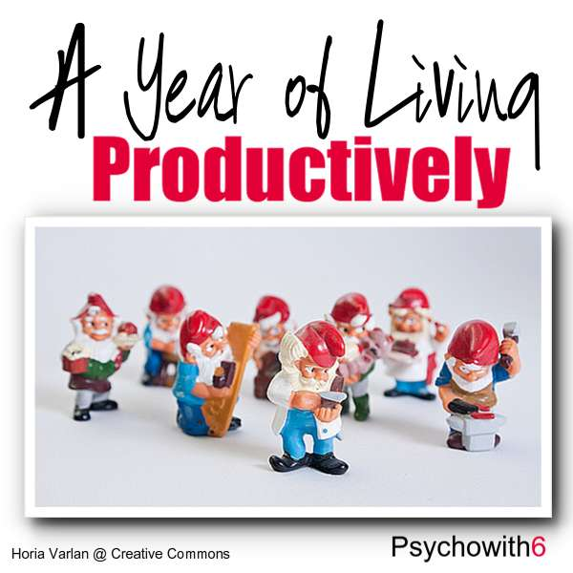

A Year of Living Productively
Week 1: Paper To-Do List
Week 2: Covey's Quadrants
Week 3: Routines
Week 4: Paper Planner
Week 5: SMEMA
Week 6: Guilt Hour
Week 7: Envision Ideal Day
Week 8: Do it Tomorrow
Week 9: Pomodoro
Week 10: Time Warrior
Week 11: Scheduling
Week 12: The Repeat Test
Week 13: Personal Kanban
Week 14: Eat That Frog
Week 15: Vacation
Week 16: David Seah's7:15AM Ritual
Week 17: Another Simple and Effective Method
Week 18: Daily/Weekly/Monthly To-Do List
Week 19: Ultimate Time Management System
Week 20: Getting Things Done
Week 21: Time Blocking
Week 22: Morning Ritual
Week 23: Beat the Week
Week 24: Productivity Ritual
Week 25: Make it Happen in 10 Minutes
Week 26: Focus & Relief List
Week 27: Accountability Chart
Week 28: Limiting Choices
Week 29: Zen to Done
Week 30: Heatmapping
Week 31: Gamification
Week 32: The 12 Week Year
Week 33: David Seah's Ten for Ten
Week 34: David Seah's Emergent Task Planner
Week 35: Steve Kamb's Do It Now
Week 36: Rising Early
Week 37: Computer Shortcuts
Week 38: Interrupter's Log
Week 39: Project Management
Week 40: Little and Often
Week 41: Problem Solving Approach
Week 42: Inbox Zero
Week 43: Resistance List
Week 44: Time Tracking
Week 45: No To-Do List
Week 46: Delegating
Week 47: Advanced Scheduling Guest Post
Week 48: Goal Setting Guest Post
Week 49: 7 Habits Guest Post
Week 50: Christian Perspective Guest Post

